Access Key

**Activity 1: Rotate the access keys**

Before Rotation:

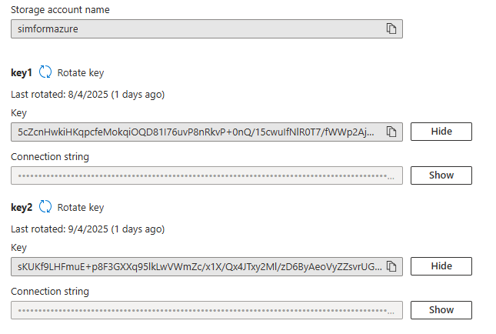

After Rotation:

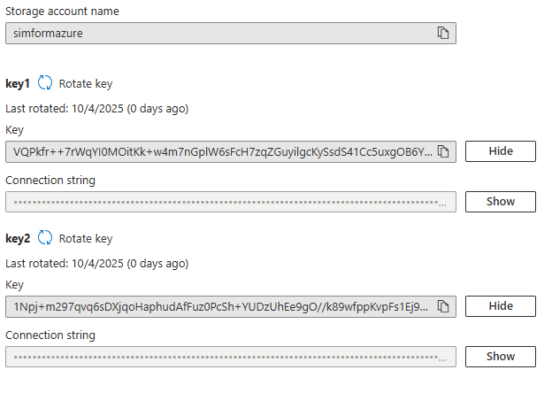

**Activity 2: Set a remainder for key rotation every 60days.**

